Last Name: |  | First Name: |  | Gender: M / F
Address: |  | City, Province: |  | Postal Code:
Phone (Home) ( ) |  | Phone (Work) ( ) |  | Phone (Cell) ( )
Alberta Health Care # |  |  | Third Party Insurance #
Emergency Contact Name: |  |  | Emergency Contact Phone ( )
Date of Birth: | Age: |  | Height: |  | Weight:
Occupation: |  |  | Marital Status: Single Married Widowed Divorced Common Law
Reminders: Text Message / Email |  |  | Cell Phone Provider (Telus, Rogers, Bell etc.):  Email:
Please check all answers and fill in the blanks where appropriate.
Reason(s) for appointment:
When did your condition begin?
Have you ever had similar problems? Yes No
Have you had X-rays, MRI, or other tests for this condition? Yes No which tests, when?
How did you hear about us?
Is this a work related injury? Yes No Has your employer been notified? Yes No
Is this a Motor Vehicle Accident (MVA)? Yes No On what date did the accident occur?
Can you perform daily home activities? Yes Yes, but only with help Not at all
Can you perform your daily work activities? All activities Only some activities Not at all
Describe your stress level None Mild Moderate High
Do you exercise? Daily Occasionally Not at all
What kinds of exercise do you do?
List all previous surgeries, illnesses, injuries (including MVA):

Have you had previous chiropractic care? Yes No Dr. Date:
Family doctor name: Dr.
List all medications, over the counter and prescriptions, supplements, vitamins, herbal supports, aspirin, etc.:

Date: Patient signature:
Health Questionnaire
Have you ever been diagnosed or told you have any of the following? Circle the correct response.
- High blood pressure Yes No
- Hardening of the arteries (arteriosclerosis) Yes No
- Diabetes Yes No
- Tuberculosis Yes No
- Cancer Yes No
Where?
- Heart or blood diseases Yes No
- Bone spurs on the neck bones (cervical sprain) Yes No
- Whiplash injury (flexion-extension injury, cervical sprain) Yes No
- Have you or any of your relatives ever suffered a stroke? Yes No
- Were you ever a smoker? Yes No
From to
- Do you take medication on a regular basis? Yes No
- Visual disturbances (blurring, loss, double vision) Yes No
- Hearing disturbances (loss, ringing, other noise) Yes No
- Slurred speech or other speech problems Yes No
- Difficulty swallowing Yes No
- Dizziness Yes No
- Loss of consciousness, even momentary blackouts Yes No
- Numbness, loss of sensation, loss of strength or weakness in the face,
fingers, hands, arms, legs, or any other parts of the body? Yes No
- Sudden collapse without loss of consciousness Yes No

Indicate the location of your pain by shading in the appropriate area(s):
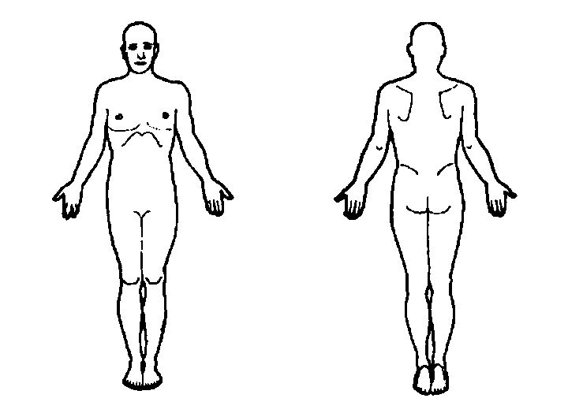
Indicate the severity of the pain by circling a number:
| 0 1 2 3 4 5 6 7 8 9 10 |
No pain Extreme pain

