

**Northwest Wellness Centre**

***Personal Information*** **Date:­­__________**

Last Name:__________________ First Name:_____________ Middle Initial:_____

Date of Birth(d/m/yyyy):_____________ Age:______  Female  Male

Marital Status:_______ Height(ft’,in”):_________ Weight (lbs): _________

Mailing Address:_______________________________________________________

Postal Code:____________ Occupation:___________________________________

Home #:_________________ Work#:________________ Cell#:_________________

Emergency Contact name:______________ Relationship:__________ Phone#:________

I would like to receive reminders by Email Text Message

Yes, I would like to receive occasional emails with the latest news and updates from

Northwest Wellness Centre including events, new services, health tips, and promotions.

Email Address:___________________________________ Cell Provider_________

**Confidential Consent Form**

**for Massage Therapy**

The massage therapist respects the patient’s right to an informed and voluntary consent regarding care and treatment by obtaining his/her consent before providing treatment.

Your comfort and trust in the massage therapist is extremely important in providing an optimal patient/therapist relationship.

The treatment will be provided only when there is reasonable expectation that the treatment will be beneficial to the patient.

Before, during and/or after therapy, we encourage you to communicate to the therapist any aspect of the treatment in which you have concerns and/or questions.

Proper draping is always provided to ensure safety, comfort and privacy for all patients. Patients will be asked to disrobe in private and prepare themselves on the massage table. You may choose to remove or leave on clothing, according to your comfort level.

I understand that my massage therapist in *not* a physician and *cannot* diagnose or prescribe towards any medical conditions or disease. I understand that it is my responsibility to notify the therapist of any changes in my health or medical history. I understand that it is ultimately my responsibility to notify the massage therapist if I am ever in any discomfort or pain. I understand that any soreness or adverse medical condition incurred during my massage will be at my fault alone. I hereby state that I have read the information above and have provided all notable information to the best of my knowledge.

I, ________________________________ (print name) have read and understand my rights and consent to this, as well as, future treatments.

Signature: ________________________________ Date :____________________________________

Indicate the location of your pain by shaping in the appropriate area.

**Health Questionnaire**

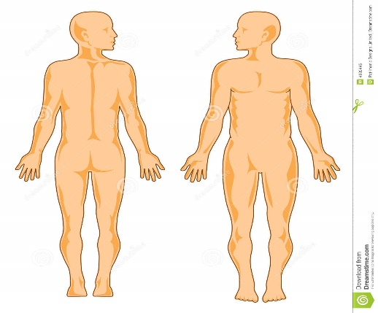 Comments:________________________

__________________________________

__________________________________

__________________________________

__________________________________

Are you taking medication? If so for what reason?

_________________________________

Indicate the severity of pain by circling a number

1 2 3 4 5 6 7 8 9 10

No Pain Extreme Pain

__________________________________

__________________________________

***Have you ever been diagnosed or told you have any of the following?***

1. High Blood Pressure Yes  No
2. Heart Trouble Yes No
3. Varicose Veins Yes No
4. Rheumatic Fever Yes No
5. Kidney/Bladder Trouble Yes No
6. Gall Bladder/Liver Trouble Yes No
7. Stomach Ulcer Yes No
8. Nausea or Vomiting Yes No
9. Sinus Trouble Yes No
10. Lung Trouble Yes No
11. Shortness of Breath Yes No
12. Anemia Yes No
13. Unusual Weight Loss Yes No
14. Diabetes Yes No
15. Tuberculosis Yes No
16. Cancer/Tumor Yes No
17. Stroke Yes No
18. Epilepsy Yes No
19. Allergies Yes No
20. Skin Rash Yes No
21. Rheumatism/Arthritis Yes No
22. Rupture/Hernia Yes No
23. Trouble Sleeping Yes No
24. Fainting/Dizzy Spells Yes No
25. Numbness/Tingling Yes No
26. Weakness in Arms or Legs Yes No
27. Cramps or Spasm Yes No
28. Swelling/Inflammation Yes No
29. Dislocation of Joints Yes No
30. Broken Bones Yes No
31. Back/Neck Pain Yes No
32. Chest Pain Yes No
33. Back/Neck Injury Yes No
34. Arm/Leg Injury Yes No
35. Head Injury Yes No
36. Nervous Disorder Yes No
37. Severe Headaches Yes No
38. Hard of Hearing Yes No
39. Eye Trouble Yes No
40. Ear Trouble Yes No
41. Jaw Noises or Pain Yes No
42. Knocked out/Unconscious Yes No

Please Remark On all Yes Answers:________________________________________________

______________________________________________________________________________

***Females:*** Date of last menstrual period:__________ Are you pregnant now:____________ How many children do you have:_______

*\*Please inform us if you become pregnant or plan to become pregnant*

What type of massage atmosphere do you prefer? Silent  Minimal Talking  No Preference 

What type of massage are you looking for? Relaxation  Deep tissue  No Preference 

**Northwest Wellness Centre**

**Massage Fee Schedule**

**Visit Charges Student Pricing**

30 minutes $70 60 minutes $50

45 minutes $80 **Thai massage:**

60minutes $100 60 minutes $80

90 minutes $140 90 minutes $110

(please note that we **can’t** direct bill for student massage, will need to be paid for out of pocket)

**Legal Reports and insurance forms are subject to a fee.**

Our office will bill directly, on the patient`s behalf of **Alberta Blue Cross, Alberta School Employee Benefit Plan, Greenshield, SSQ Insurance, RCMP, VETS (Medavie), Sun life, Canada Life, Manulife, Maximum benefit, Group Health, Group Source, Chamber of Commerce, First Canadian, CINUP, Claim Secure, Telus Adjudicare, Industrial Alliance, Johnson Inc., and other insurance companies**.. Please check with your health care provider for massage therapy coverage as individual insurance policies may vary.

**We understand that there will be circumstances for which you may not be able to keep your appointment; we require 24 hours notice for cancelation or you will be charged half of your appointment fee.**

**Consent**

I have read the above and understand and agree that all services rendered to me are charged directly to me and I am personally responsible for payment.

Signature:______________________ Date: ________________